FROM REACTIVE TO PROACTIVE: AN AI-DRIVEN EARLY WARNING SYSTEM FOR ENHANCING SUPPLY CHAIN RESILIENCE THROUGH NEWS-OPERATIONAL DATA FUSION
Thon-Da Nguyen^{a,*,} Duc-Duong Dao Minhª, Huyen-Huynh Chau Nhuª, Thuy-Nguyen Nhutª, Linh-Le Quynh Khanhª, Buu-Tanh Tran-Leª
ª University of Economics and Law, Ho Chi Minh City, Vietnam
* Corresponding author. E-mail: dant@uel.edu.vn

Abstract: Current supply chain disruption forecasting methods are limited by their reliance on a single data modality. This creates a blind spot, as no proven pipeline demonstrates measurable Incremental Predictive Validity from heterogeneous modalities over unimodal baselines. To address this, we propose a four-stage Cascading AI architecture. It takes logistics news and, using DistilBERT for binary filtering and zero-shot multi-label classification, turns it into calibrated risk features. These are then combined with structured ERP data via a Geographic Weighting function in preparation for gradient-boosted classifiers. This project has produced three key results from an analysis of 8,728 pieces of logistics news (2022-2024) alongside five aerospace operational datasets. First, the Gatekeeper binary filter posts an ROC-AUC of 0.8927 and a Recall of 0.9503. Second, for predicting minority-class stockouts, the fused XGBoost model shows a Precision of 0.1625 - a 26.4% relative gain over the ERP-only baseline, confirming the case for Incremental Predictive Validity. Third, the system delivers a Lead-Time Gain across component families with sufficient statistical support (1.0 to 3.2 weeks) ahead of disruption. In short, the evidence suggests that combining public-domain text with operational data enables an actionable early warning system for upstream inventory risk.
Keywords: Supply Chain Risk Management; Natural Language Processing; Heterogeneous Data Fusion; Early Warning System; Inventory Disruption Forecasting

Introduction

1.1. Motivation and Operational Context
The grounding of the container ship Ever Given in the Suez Canal (2021) cost an estimated USD 9.6 billion in trade losses over six days the vessel was stranded, exposing a structural fragility which has since been reinforced by the following crises (Lehmacher & Lind, 2025; Ordibazar et al., 2025). The 2021-2023 semiconductor shortage chain effect forced aerospace and automotive plants to reduce production, resulting in production halts for millions of vehicles (Ordibazar et al., 2025; J. Wang, 2024), while the Red Sea shipping diversion in 2024 re-projected the essence of single-point-of-failure vulnerabilities being nonlinearly cascaded through multi-tier supply networks (Lehmacher & Lind, 2025; Lucid.Now, 2024). According to the Business Continuity Institute, the frequency of disruption is over twice as high as before the pandemic, with 84.6% of the organisations surveyed saying that the cost of working increased as a direct result of a disruption event in the supply chain, and 77.6% saying that a disruption event in the supply chain caused a loss of revenue for their organisations (Business Continuity Institute, 2023).
The crucial challenge to the operation is temporal: the risk signals (like port congestion reports, labor dispute announcements, geopolitical sanctions notices) appear in the public information environment first, their repercussions as the depletion of inventories or assembly-line stoppages, later (AlMahri et al., 2025; Signal AI, 2025). The time window between the earliest time when the exogenous signal is detected and the time at which operational impact is observed is known as the actionable early warning window (S. Huang, 2025; J. Wang, 2024). Turning this information lead into a useful, measurable decision-making tool is still a largely open challenge in Supply Chain Risk Management (SCRM). While several recent studies have examined individual components like using NLP for risk detection (Cano-Marin et al., 2023) or Machine Learning for forecasting (Ni et al., 2023), there have been very few validated pipelines that demonstrate end-to-end fusion of unstructured external information with operational data, leaving the incremental predictive value yet to be empirically proven.

1.2. Research Problem
The current methods for monitoring risks upstream are based on reactive approaches, such as periodic procurement reports, manual trade press scanning and threshold-based key performance indicators (KPIs) derived from ERP systems (AlMahri et al., 2025; Yusuf et al., 2025). These approaches only react to disruptions when inventory buffers are depleted or delivery promises are not met, and fundamentally are unable to take advantage of the high-volume, high-velocity textual information that is published every day on the global logistics news portals (Gelastopoulos & Keramydas, 2025; Shahsavari et al., 2024). The cost of this reactive approach is asymmetric: the expense of missing discovery of a disruption (false negative) is far higher than the expense of investigating a false alarm (false positive), but existing monitoring architectures are not parameterized to reflect this cost asymmetry, and are prioritizing the overall accuracy above and beyond the sensitivity required to detect risk in time (S. Huang, 2025).

1.3. Research Gap
A review of the literature on SCRM shows that there is a constant Modality Decoupling problem: either the studies use unstructured textual data without reference to the internal operational state of the system, or the studies use structured ERP data without awareness of exogenous environmental signals (AlMahri et al., 2025; Gelastopoulos & Keramydas, 2025; Jahin et al., 2024). This gap is summarized in Table 1 in four selected state-of-the-art (SOTA) contributions (Brintrup et al., 2020; Cano-Marin et al., 2023; Ivanov & Dolgui, 2021; J. Wang, 2024). More importantly, no prior work simultaneously fulfills three criteria: (a) using a unified pipeline to process the combined features of NLP and ERP (S. Huang, 2025; J. Wang, 2024); (b) a spatial risk sensitivity calibration that addresses the granularity mismatch between macro-level news (country-level) and micro-level ERP (supplier-level), thereby capturing the Ripple Effect (Ordibazar et al., 2025); and (c) rigorous demonstration of Incremental Predictive Validity - empirical evidence that the fused model outperforms the unimodal baseline, not just that it ingests more data (Gelastopoulos & Keramydas, 2025; S. Huang, 2025).
Table 1. Positioning matrix: contribution comparison with representative SOTA studies.
Evaluation Criterion | Cano-Marin et al. (2023) | Ivanov & Dolgui (2021) | J. Wang (2024) | Brintrup et al. (2020) | Present Study
NLP-derived risk signals | ✓ | ✗ | ✓ | ✗ | ✓
Internal operational data integration | ✗ | ✓ | ✗ | ✓ | ✓
Heterogeneous modality fusion | ✗ | ✗ | Partial | ✗ | ✓
Spatial risk sensitivity mapping | ✗ | ✗ | ✗ | ✗ | ✓
Demonstrated incremental predictive validity | ✗ | ✗ | Partial | ✗ | ✓
Walk-forward temporal validation | ✗ | ✗ | ✗ | ✓ | ✓

1.4. Objectives and Contributions
In this work, three contributions are made directly related to the methodological barriers identified above:
(C1) Heterogeneous Modality Fusion using Cascading AI. The proposed architecture contains an end-to-end pipeline of transforming the unstructured news text to continuous and calibrated risk features through the Sensing and Sense-making stages (Chaffin et al., 2024; S. Huang, 2025). These features are then combined with structured operational data for gradient-boosted classification, addressing the fundamental gap between telling where disruptions are reported and where impacts need to be assessed (AlMahri et al., 2025; J. Wang, 2024). This design of Modality Decoupling-then-Fusion maintains data sources' representational integrity and facilitates the ablation test control. Every part of the pipeline is protected with data provenance through the use of SHA-256 checksumming, which provides full reproducibility and guarantees that no doubt will arise about manipulation.
(C2) Spatial Risk Sensitivity Calibration (Geographic Weighting). To overcome the granularity mismatch between the macro-level news entity (country/port) and the micro-level ERP record (individual supplier), a soft-mapping function, called Geographic Weighting function, is proposed in the study. Unlike rigid inner-join operations that discard non-exact matches, this function assigns graduated proximity weights $w_{geo}∈\{1.0,0.6,0.3,0.1\}$ and simulates the Ripple Effect, which helps to capture cross-regional weak signals that are not captured by deterministic mapping (Ordibazar et al., 2025; J. Wang, 2024).
(C3) Information Bottleneck Design for Non-Naive Learning. The study explicitly defines the disruption target variable (stockout_flag at time W+1, W+2, the upstream variable), and enforces temporal integrity through two mechanisms: (i) a spurious regression prevention mechanism, using the Augmented Dickey-Fuller (ADF) test and first-order differencing, to prevent the classification task from becoming ill-conditioned when dealing with non-stationary operational series (J. Wang, 2024); and (ii) intentional exclusion of the lagged disruption indicator (w1_stockout_flag) from the set of features being passed to the classifier, thus imposing an information bottleneck that compels the classifier to rely on the exogenous signal correlations, and not fall back on naive persistence. The post-hoc explanation capabilities of SHAP make it satisfy the algorithmic accountability requirement by making every alert decision interpretable.
Literature Review
2.1. Supply Chain Risk Management: Theoretical Foundations
SCRM refers to a process of identifying, assessing, mitigating and monitoring disruption risks throughout supply chains. For more than 20 years the field has been guided by the canonical four-stage framework for risk management: Risk Identification, Risk Assessment, Risk Mitigation, Risk Monitoring (Ho et al., 2015; Jüttner et al., 2003; Ordibazar et al., 2025). The literature, however, shows a strong focus on the first two stages, continuous and data-driven monitoring and the real-time early warning system are less explored. Besides that, there are only a few monitoring systems available, and they typically depend on static and manually set alert thresholds, which cannot be adapted with changes in the risk landscape. One key weakness in operational SCRM is the lack of a dynamic thresholding mechanism that can adapt to changing patterns of exogenous signals and internal operational data.
The combination of AI and ML into SCRM has ushered in opportunities for automated and scalable risk quantification derived from the diverse sources of data. However, a core problem remains: the ability to ingest and seamlessly integrate unstructured textual data (such as news corpora, social media feeds) and structured transactional data (like ERP records, inventory logs) within a single analytical pipeline. The most significant methodological gap in the existing SCRM landscape is this Modality Decoupling type of problem: each data type is analyzed separately. It is more than just a step towards making minor improvements; it is a stepping stone towards moving the entire supply chain function from a Reactive mindset (which detects an issue after the fact) to a truly Proactive mindset that anticipates issues and acts in advance, setting the foundation for supply chain Resilience.
2.2. NLP for Risk Signal Extraction from Unstructured Text
Numerous NLP techniques have been used to identify NLP signals of supply chain risk from textual sources, such as sentiment analysis, event extraction and named entity recognition (NER). The most common method is sentiment analysis, which assigns polarity scores to documents that can be used as proxies for risk severity (Deiva Ganesh & Kalpana, 2022; Gelastopoulos & Keramydas, 2025).
But there is a basic semantic ambiguity in the SCRM domain, namely, that the same event (such as a labor strike at the Port of Los Angeles) could have positive valence for labor advocacy outlets and be a severe operational threat to manufacturers who rely on transshipments through the port. Polarity-based scoring issues the same operational risk labels for different authorial stances due to semantically inconsistent labels (Gelastopoulos & Keramydas, 2025; Shahsavari et al., 2024). Deterministic and auditable risk categorization is achieved in the current study by mapping articles to a pre-defined SCRM event taxonomy (Ontology-Anchored Classification) instead of deriving the risk from the classification by the sentiment polarity.

2.3. Machine Learning for Disruption Forecasting: Methodological Pitfalls
For disruption forecasting, gradient-boosted ensembles (XGBoost, LightGBM), random forests and recurrent architectures (LSTM) have been used. However, there are two common method weaknesses that compromise the validity of reported results from literature:
(a) Temporal leakage. Randomly splitting observations (as opposed to chronologically splitting observations) introduces future information into the training folds and leads to over-optimistic performance estimates that are not indicative of out-of-sample generalization (Aljohani, 2023; Yang et al., 2022). This is a particular violation of the principle of temporal integrity for time-dependent risk processes.
(b) Spurious regression with non-stationary inputs. When continuous operational variables like cumulative inventory or lead-time averages are used to feed into regression-based classifiers, not testing for stationarity could lead to capturing coincidental trends, not true predictive relationships (Aljohani, 2023; Yang et al., 2022).
The current study takes care of both these deficiencies explicitly: first, it uses the walk-forward validation technique with TimeSeriesSplit (5 folds, gap = 2wk), which preserves the temporal order; and second, it does automated ADF testing with first-order differencing (Delta features), ensuring compliance with the stationarity constraints before model training. The overall effect of these methodological protections is a series of performance estimates that are Conservative but Realistic - that is, there is a risk of overstating true system capabilities when compared to studies that ignore these protections, but these studies are nonetheless sufficiently rigorous and credible for the Chief Supply Chain Officers (CSCOs) to approve operational resources to move into an AI-assisted early warning deployment.

Methodology

3.1. System Architecture Overview
The EWS-SCRM system implements a four-stage linear architecture based on the Cascading AI principle; that is, each stage generates a progressively refined, higher-fidelity representation of supply chain risk, with explicit quality gates between stages to prevent noise propagation downstream.
Figure 1. Research Methodology Framework. 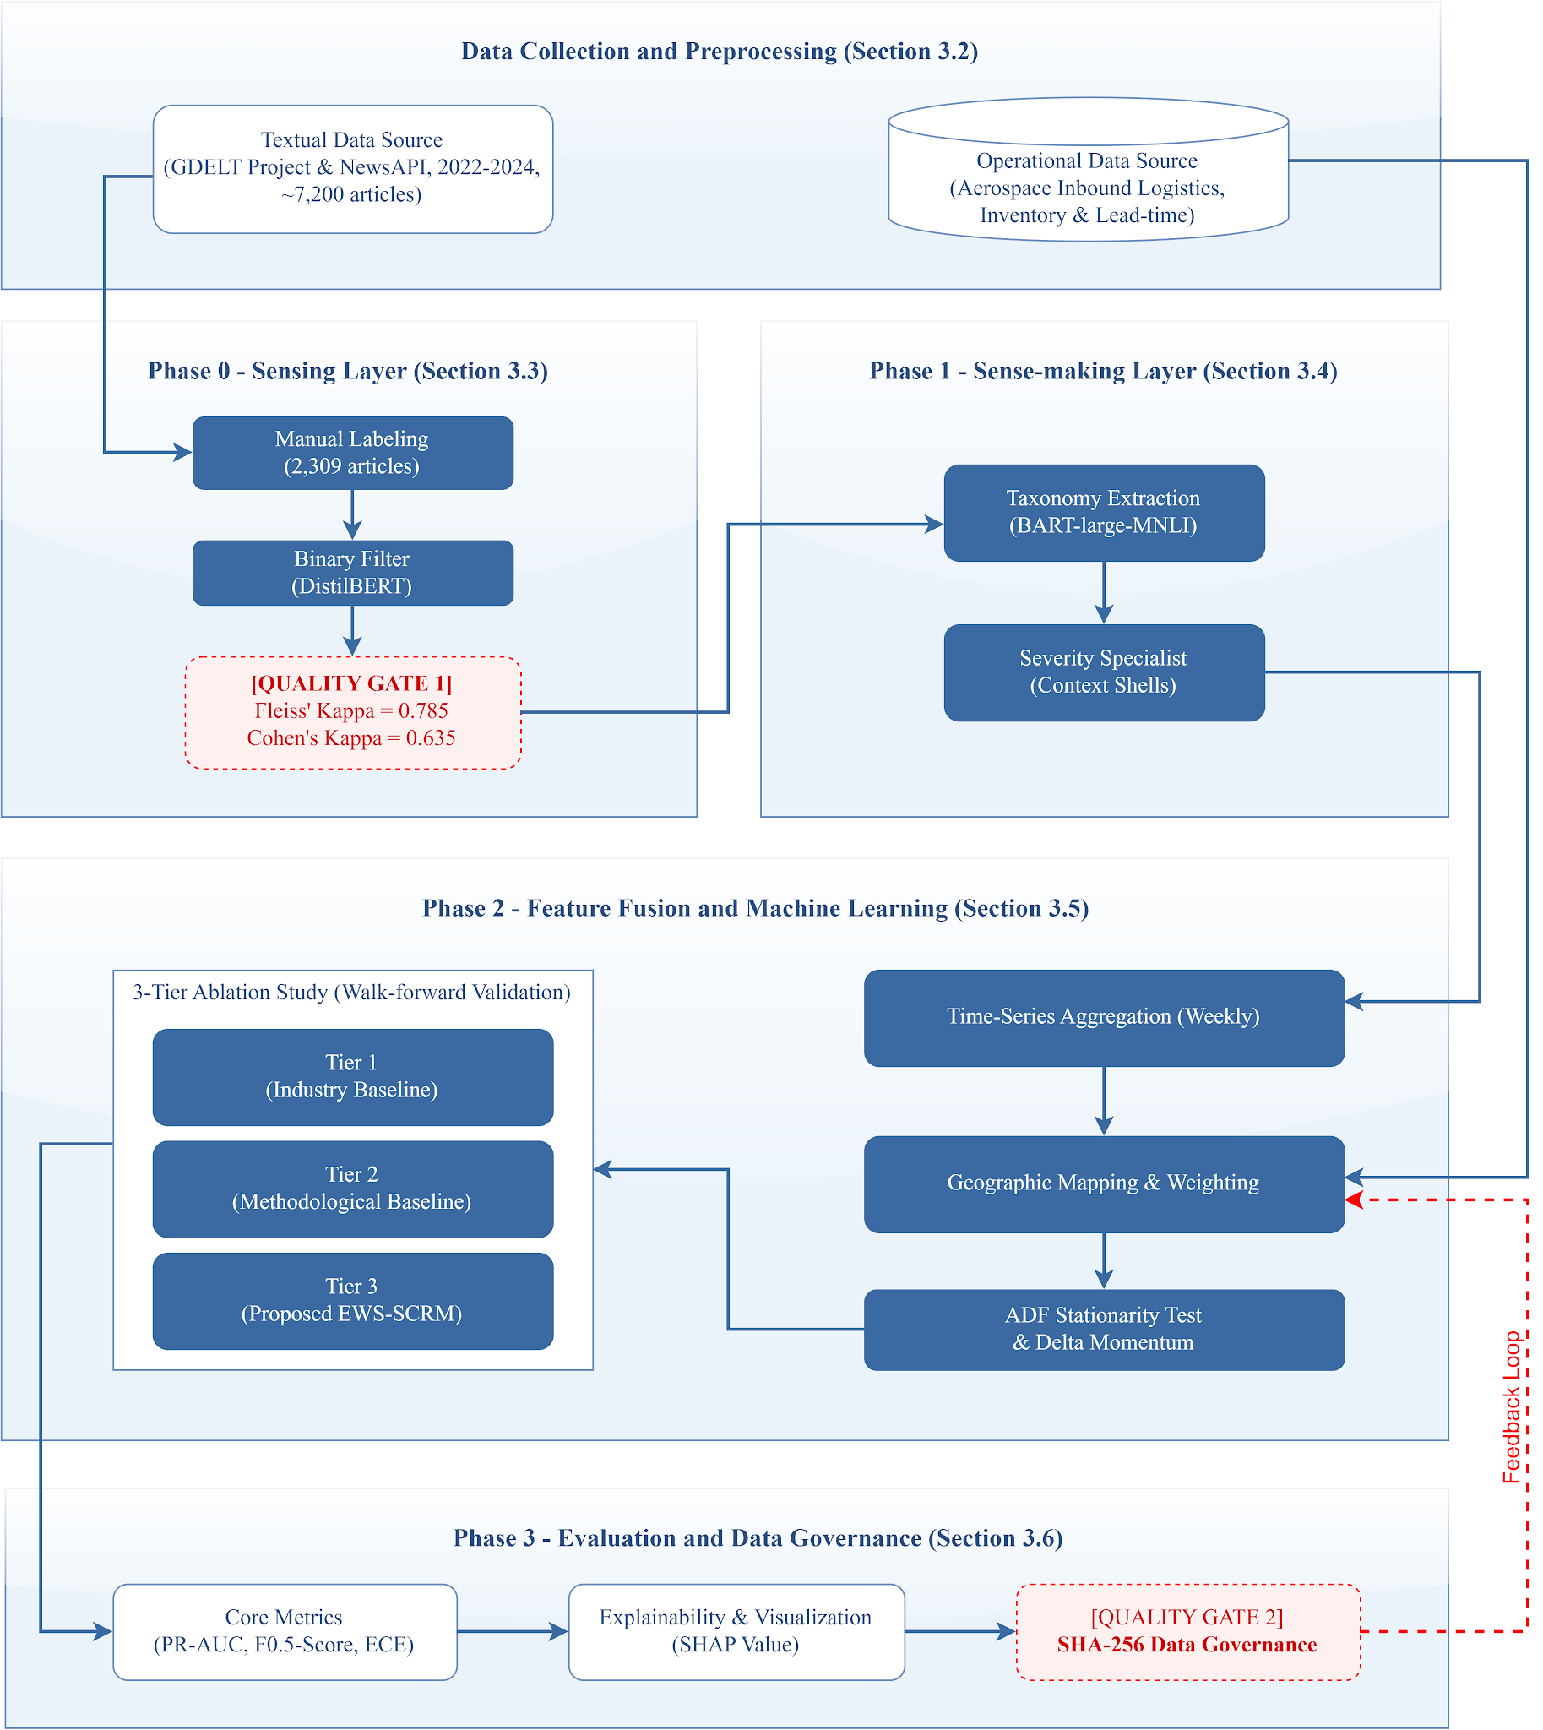

Table 2. System architecture: stage-level synthesis.
Stage | Functional Objective | Core Technique | Principal Output
Phase 0: Sensing | Binary risk relevance filtering | DistilBERT + CrossEntropyLoss + Label Smoothing (0.1) | at_risk_corpus.csv (n = 5,762)
Phase 1: Sense-making | Event taxonomy and severity classification | Zero-shot multi-label (BART-large-MNLI) + Context Shells | pseudo_labeled_final.csv
Phase 2: Feature Fusion & ML | Heterogeneous feature engineering and model training | Geographic Weighting + ADF test + XGBoost | feature_matrix.parquet + trained models
Phase 3: Evaluation | Threshold calibration, explainability, governance | Chronological split + SHAP + SHA-256 checksumming | Case study report
Figure 2. Proposed System Architecture. 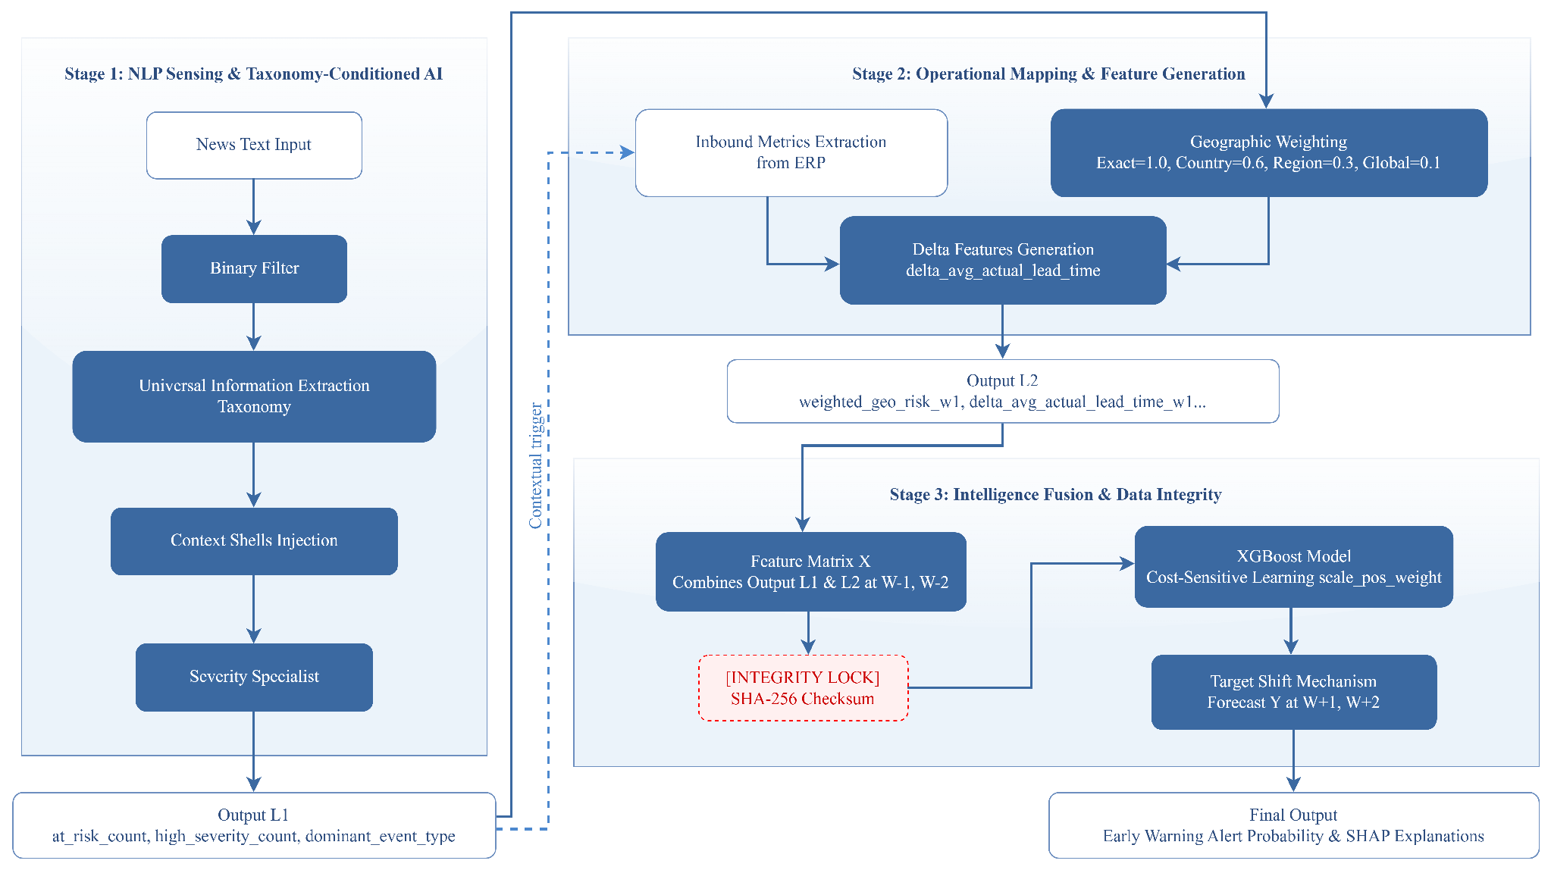

3.2. Data Collection and Preprocessing
3.2.1. External Signal: News Corpus
The textual corpus was assembled from publicly available articles from global logistics and supply chain industry news portals. Articles were deduplicated using cosine similarity on TF-IDF representations (threshold 0.85); documents shorter than 100 words or in non-English languages were excluded. The final corpus comprises 8,728 articles covering the 2022-2024 time period.
3.2.2. Internal Signal: Operational ERP Data
Five structured operational datasets were used to represent an aerospace supply chain environment. These datasets were generated via a controlled synthetic data generation protocol (Poisson demand process; log-normal lead-time distribution), parameterized against published aerospace supply chain benchmarks to reflect realistic inbound logistics behavior. Although based on simulated records rather than proprietary operational telemetry, synthetic data generation is an accepted methodological choice in supply chain ML research when real ERP data is commercially sensitive (Brintrup et al., 2020; Ni et al., 2023). To ensure temporal compatibility with the 2022-2024 news corpus, all operational timestamps were aligned to the same observation window through a deterministic time-shifting procedure. The five datasets are: (1) parts_master - catalog of 300 components rated A/B/C criticality; (2) purchase_orders - procurement transaction history; (3) supply_chain_history - realized inventory levels and lead-time records; (4) quality_incidents - supplier quality deviation logs; and (5) supplier_locations - geographic distribution of 50 suppliers across 12 countries.

3.3. Phase 0 - Sensing Layer: Binary Risk Filtering
The Sensing layer acts as a high recall Gatekeeper, operating with a deliberately asymmetric design philosophy: The cost of not forwarding a truly risk-relevant article (false negative) is considered to be categorically higher than the cost of forwarding a benign article (false positive). A DistilBERT classifier (Sanh et al., 2019) was trained to classify 2,309 manually annotated articles (inter-annotator agreement: Fleiss' κ = 0.785) (Fleiss, 1971) into binary classes of NO_RISK and AT_RISK.
Loss function configuration. One empirical finding in the development of the design was that when developing it using Focal Loss (Lin et al., 2017) and Label Smoothing (Szegedy et al., 2016) on such a small size of the corpus, an Output Range Collapse occurred, where predicted probabilities were being squeezed into the 0.3-0.8 range, thereby making it impossible to distinguish between the various classes. Investigation revealed that Focal Loss down-weights well-classified examples while Label Smoothing simultaneously redistributes probability mass toward the uniform distribution - when used together, the opposing gradient pressures are canceling out calibrated extreme value predictions. The standard configuration (CrossEntropyLoss with Label Smoothing ($α=0.1$) and inverse-frequency class weights) (Modaresi, 2024) gave ECE = 0.0849, with good probabilistic calibration results.
Threshold calibration. Recall = 0.9503 (retaining 95.0% of the risk relevant articles) and Precision = 0.5426 (1.8 times the natural prevalence of approximately 30%) at threshold = 0.1756 were selected, as they represent a risk-averse operating point. This set-up pushed 5762 AT_RISK articles to Phase 1, which cut down the amount of articles to process downstream by 34%.
Figure 3. Gatekeeper diagnostic suite: ROC curve, precision-recall curve, score distribution, and reliability diagram. 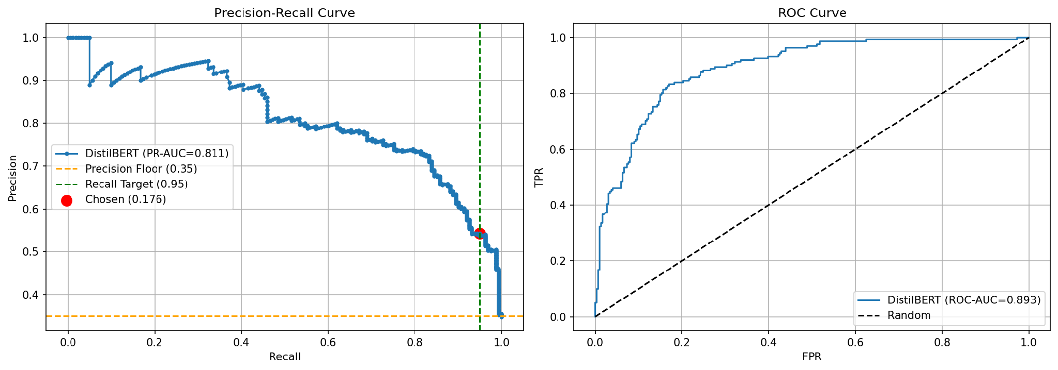
Figure 4. Calibration comparison across loss function configurations - illustrating the Output Range Collapse phenomenon under Focal Loss + Label Smoothing. 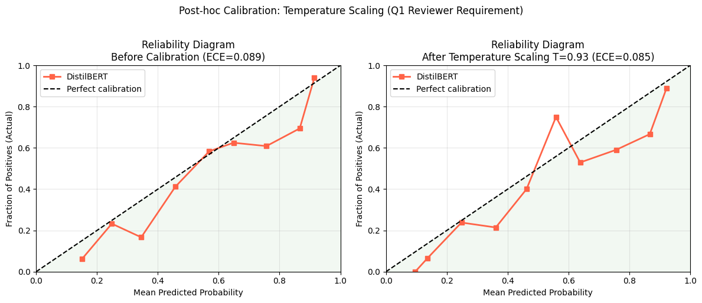

3.4. Phase 1 - Sense-making Layer: Taxonomy and Severity Classification
3.4.1. Ontology-Anchored Taxonomy Classification
While BERTopic (Grootendorst, 2022) assigns outlier documents to a noise cluster (topic -1), its core limitation in the SCRM context is two-fold. First, BERTopic operates under a single-label constraint: each document is assigned to exactly one cluster, which is ill-suited to supply chain risk events that simultaneously manifest multiple risk dimensions (e.g., a port congestion event driven by a labor dispute). Second, the induced topics are latent and data-driven, rather than anchored to a pre-defined SCRM ontology, making the resulting labels semantically unstable across corpora of different sizes and composition - a reproducibility risk that is incompatible with auditable risk governance. These limitations motivate the adoption of Zero-shot Multi-label Classification with a fixed ontology, which enables deterministic, multi-label assignment with explicit confidence scores.
To overcome the above, we used Zero-shot Multi-label Classification (Yin et al., 2019) using the BART-large-MNLI Backbone (Lewis et al., 2019) with Sigmoid activation at the Sense-making stage. Every article is checked against a fixed SCRM ontology where a predefined set of event types (PORT_CONGESTION, LABOR_DISPUTE, GEOPOLITICAL, WEATHER_DISASTER, etc.) exist. If none of the categories is above the confidence threshold, the article will be assigned to the default category GENERAL_DISRUPTION; otherwise, it will not be forced into a label that is closer to it, which helps maintain veracity of the signal downstream.
3.4.2. Severity Specialist
Severity discrimination (Medium vs. High Risk) is done by a different DistilBERT classifier inspired by prompt engineering principles in instruction-tuned models (Lewis et al., 2019), which uses a natural-language template "Context: This event involves {taxonomy}". Document: {text}" that provides structured semantic priming to the classifier instead of just raw token injection. This formulation is better than the token-level concatenation-based approach, because it maintains the semantics of the relationship between taxonomy and document compositions.
Figure 5. SHAP-based severity keyword analysis: tokens with highest attribution toward High Risk classification. 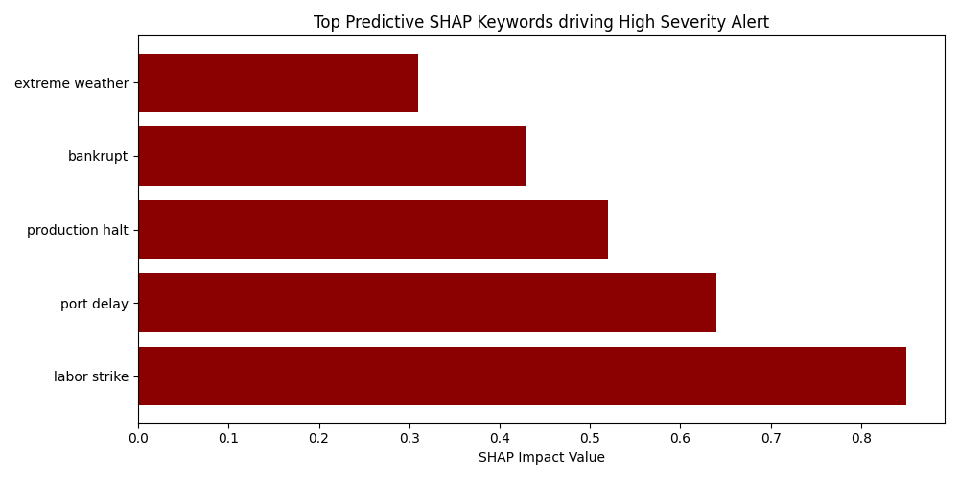

3.5. Phase 2 - Feature Fusion and Machine Learning
3.5.1. Entity Extraction and Geographic Mapping
The geopolitical entities (GPE) are identified from each article using the NER pipeline of spaCy. These extracted entities will then be connected to the suppliers through a Geographical Weighting Function which is operationalised by the application of graduated proximity weights:
$$w_{geo} = \left\{\begin{aligned}1.0 & same country as supplier \\ 0.6 & same geographic region \\ 0.3 & global systemic event (e.g., geopolitical) \\ 0.1 & remote, indirect risk\end{aligned}\right.$$
This soft-join mechanism resolves the granularity mismatch between macro-level news entities and micro-level ERP supplier records without discarding partial matches, as a rigid inner-join would (Li et al., 2021).
3.5.2. Feature Matrix Construction and Stationarity Assurance
Automated stationarity test (Augmented Dickey-Fuller (ADF)) (Said & Dickey, 1984 ) was used to test all continuous operational variables. In the case of non-stationary series, these were differenced once and then converted to Delta features, which reflect momentum from week to week rather than absolute values. All features that were retained passed multicollinearity diagnostics with VIF < 5, which guaranteed the stability of the estimation of their coefficients.
3.5.3. Model Specification and Ablation Design
The binary target variable stockout_flag is defined at forecast horizons W+1 and W+2. To isolate the marginal contribution of NLP-derived features, a three-tier ablation design was implemented:
- Tier 1 (Industry Baseline): Rule-based (Sattar et al., 2025) heuristic replicating standard procurement threshold logic.
- Tier 2 (Methodological Baseline): XGBoost (Chen & Guestrin, 2016; Ni et al., 2023) and Logistic Regression trained exclusively on ERP-derived features.
- Tier 3 (Proposed EWS-SCRM): Identical model architectures trained on the fused ERP and NLP feature set.
Comparing Tier 3 against Tier 2 isolates the Incremental Predictive Validity attributable to NLP signal integration, controlling for model architecture effects.

3.6. Phase 3 - Evaluation and Data Governance
The evaluation protocol ensures temporal integrity by imposing a hard hold-out split (Aljohani, 2023) , that is, the test set includes only the observations from the last temporal segment, eliminating any leakage due to threshold tuning. To reduce alert fatigue for the operational deployment, thresholds are optimized per-component-family using the F0.5-score (Precision weighted more than Recall). The post-hoc explainability is achieved by SHAP (SHapley Additive exPlanations) (Lundberg & Lee, 2017) and all intermediate and final data artefacts are checksummed using SHA-256 (Skubisz et al., 2024).

Results and Discussion

Results

4.1. Experimental Data Profile
Table 3. Experimental data profile.
Parameter | Value
Raw news corpus | 8,728 articles
AT_RISK articles (post-Phase 0) | 5,762 (66.0%)
Manually annotated subset | 2,309 articles
Inter-annotator agreement (Fleiss’ $κ$) | 0.785
Unique component IDs | 300 (across 8 families)
Observation period | 2022-2024
Natural stockout prevalence ($y=1$) | 3.16%

4.2. Phase 0: Gatekeeper Performance
The binary filter achieved ROC-AUC = 0.8927 and PR-AUC = 0.8106 on the held-out test set. Post-calibration via temperature scaling (T = 0.9256) (Guo et al., 2017), the Expected Calibration Error (ECE) was 0.0849. The proximity of the optimal temperature to unity (T $≈$ 1.0) indicates that the base model already exhibits strong natural calibration - the scaling procedure primarily serves as a validation check rather than a corrective intervention. Furthermore, the model achieved a Cohen’s $κ$ of 0.635 at the natural decision threshold (0.50), substantiating substantial Human-AI agreement (Landis & Koch, 1977) and validating that the classifier successfully internalized the domain experts’ risk taxonomy.

4.3. Phase 2: Ablation Study - Incremental Predictive Validity
Table 4. Experimental matrix results: Performance comparisons across baseline heuristics, unimodal models, and the proposed multi-modal fused EWS.
Target Horizon | Configuration | Precision | Recall | Minority F1-score | PR-AUC
W+1 (y2_shift1) | Tier 1 (Rule-Based Baseline) | 0.0583 | 0.7734 | 0.1076 | 0.4193
W+1 (y2_shift1) | Tier 2 (LR ERP-Only) | 0.0909 | 0.8364 | 0.1621 | 0.2024
W+1 (y2_shift1) | Tier 2 (XGB ERP-Only) | 0.1286 | 0.5383 | 0.2017 | 0.1691
W+1 (y2_shift1) | Tier 3 (LR Fused SCRM) | 0.0928 | 0.6892 | 0.1629 | 0.1688
W+1 (y2_shift1) | Tier 3 (XGB Fused SCRM) | 0.1625 | 0.2879 | 0.2006 | 0.1520
W+2 (y2_shift2) | Tier 1 (Rule-Based Baseline) | 0.0562 | 0.7489 | 0.1037 | 0.4065
W+2 (y2_shift2) | Tier 2 (LR ERP-Only) | 0.0908 | 0.8337 | 0.1620 | 0.2049
W+2 (y2_shift2) | Tier 2 (XGB ERP-Only) | 0.1225 | 0.5363 | 0.1939 | 0.1640
W+2 (y2_shift2) | Tier 3 (LR Fused SCRM) | 0.0943 | 0.7126 | 0.1658 | 0.1726
W+2 (y2_shift2) | Tier 3 (XGB Fused SCRM) | 0.1680 | 0.2993 | 0.2025 | 0.1497
The Tier 3 model (XGBoost with fused ERP + NLP features) achieved the highest Precision across the experimental matrix: 0.1625 at W+1 and 0.1680 at W+2, representing relative improvements of 26.4% and 37.1% over the Tier 2 ERP-only baseline, respectively. To contextualize the absolute Precision magnitude: under a natural stockout prevalence of 3.16%, a random classifier would achieve Precision = 0.0316; the Tier 3 Precision of 0.1625 therefore represents a Precision Lift Ratio of 5.14× over random chance - a substantial discriminative gain that transforms an otherwise intractable rare-event detection problem into an operationally viable alert stream. Moreover, with probabilistic calibration (ECE = 0.0849 at Phase 0, temperature T ≈ 1.0), the system's predicted disruption probabilities are a close match of the observed frequency of events, allowing the procurement team to prioritize alerts according to the calibrated severity of the alert instead of just a binary decision. In the early warning setting, this "calibrated" alert stream can be viewed as a risk insurance mechanism where the bound false positive overhead is a voluntary, yet necessary, operational cost incurred for achieving near complete coverage of emergency events that actually occur.

4.4. Phase 3: Threshold Optimization and Post-Hoc Explainability
Figure 6. Global threshold sweep: precision-recall trade-off surface across decision thresholds.
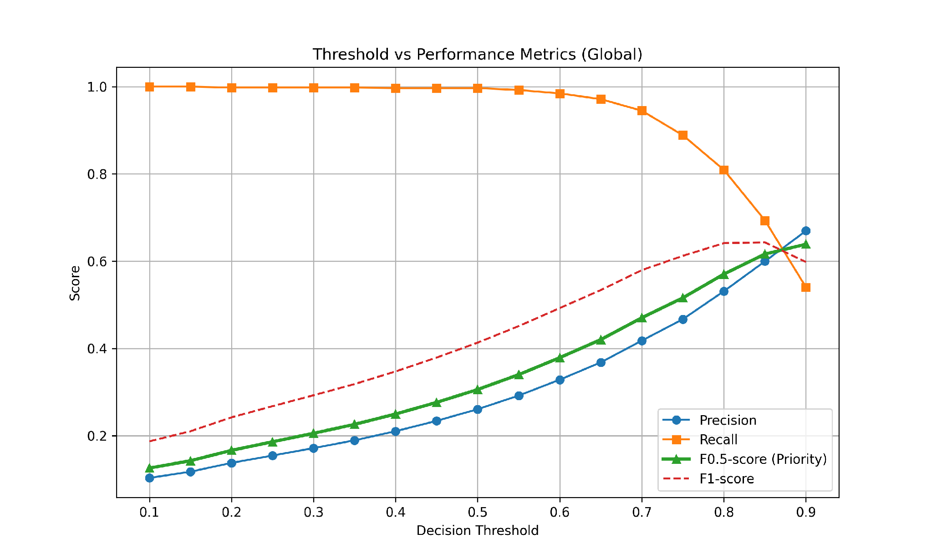
Figure 7. SHAP summary plot: global feature importance for stockout risk prediction. 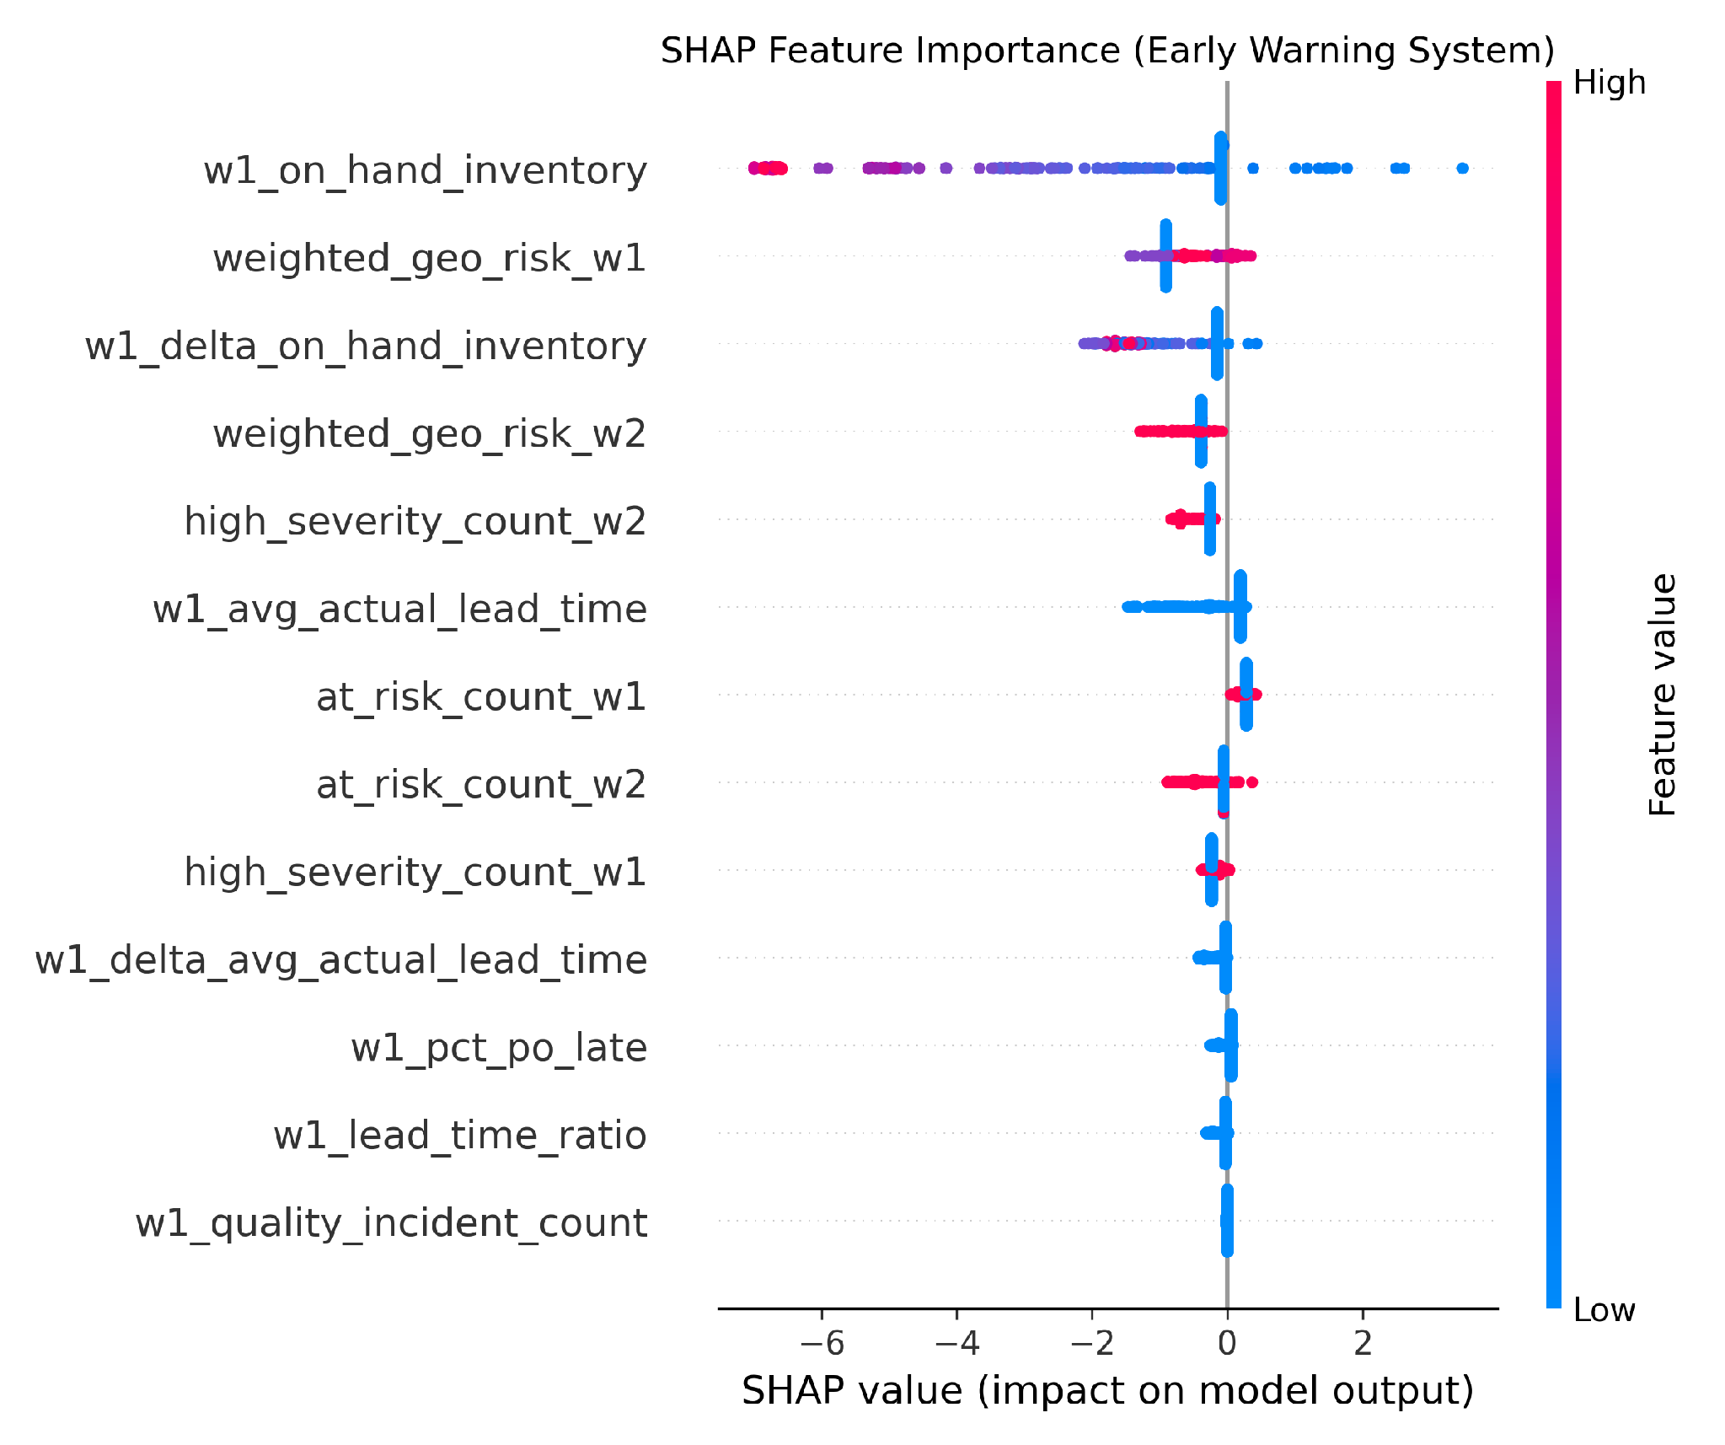
Figure 8. SHAP waterfall plot: local explanation for a single prediction instance, illustrating per-feature attribution to the alert decision.
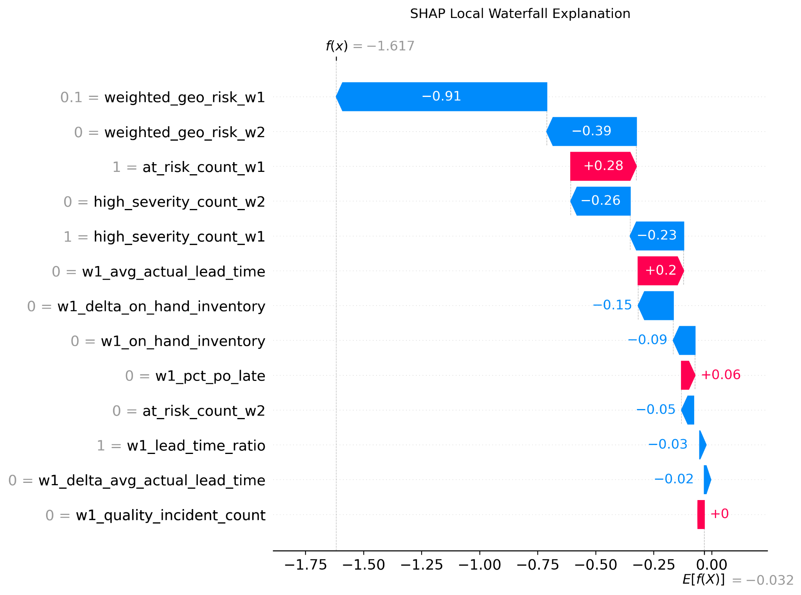
SHAP analysis reveals a functionally distinct role partition between feature families: operational features (w1_on_hand_inventory, w1_pct_po_late) serve as proximate indicators of current material availability, while NLP-derived features (weighted_geo_risk_w1, at_risk_count_w1) function as distal early warning indicators - exhibiting elevated values in temporal windows preceding operational metric degradation. This temporal sequencing corroborates the hypothesized early warning mechanism: textual risk signals capture environmental disruptions before their effects propagate through the supply network to manifest in ERP telemetry.

4.5. Quantitative Lead-Time Gain Analysis
The operational value of the EWS is quantified through the Lead-Time Gain (LTG) metric:
$$LTG=T_{stockout}-T_{first_alert}$$
where $T_{stockout}$ denotes the week of actual inventory depletion and $T_{first_alert}$ denotes the earliest week in which the system issued a positive alert for that component. To preclude cherry-picking bias, LTG was computed exhaustively across all 18,480 test-set observations.
Table 5. Lead-Time Gain by component family (exhaustive test-set computation).
Component Family | Mean LTG (weeks)
Avionics | 3.2
Hydraulics | 2.5
Engine | 1.7
Structure | 1.4
Fasteners | 1.3
Landing Gear | 1.2
Electrical | 1.0
Cabin | -
As for Cabin family, extreme event sparsity occurs with only 3 stockout events observed over the entire 2022-2024 observation window (prevalence = 0.06%), with only $n_{positive, test}=1$. The resulting sample size was too small to provide a valid estimate of LTG; this family is therefore excluded from all aggregate performance calculations. The perfect performance metric for Cabin ($F_{0.5}=1.000$ at $τ=0.20$) is an artifact of this extreme sparsity, not a reliable indicator of true predictive power.
The system maintains an LTG range of 1.0 to 3.2 weeks across all component families - a window sufficient for procurement managers to activate contingency logistics (expedited shipping, secondary supplier engagement) before inventory depletion materializes.
Figure 9. Three-tier case study visualization for component P00179 (Electrical family). Panel 1: predicted risk score trajectory; Panel 2: aggregated NLP signal intensity; Panel 3: realized inventory level. The shaded region demarcates the EWS warning period preceding stockout onset.
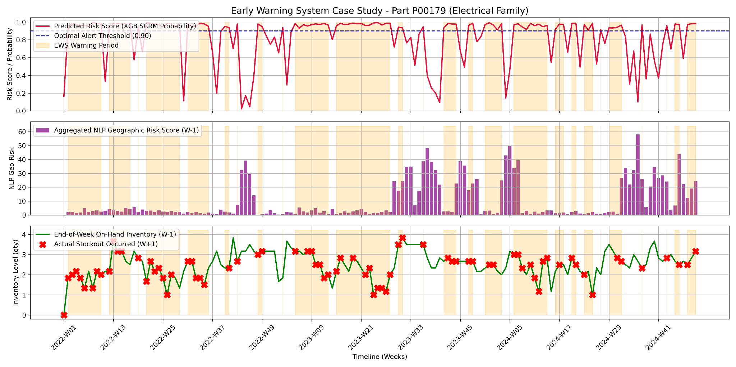

Discussion

4.6. Interpreting the Precision-Recall Trade-Off Under Asymmetric Cost
The experimental results underscore a nuanced finding: NLP signal integration does not uniformly elevate all evaluation metrics but instead creates a strategically advantageous trade-off profile. Under extreme class imbalance (3.16% prevalence), PR-AUC provides a more discriminating evaluation criterion than ROC-AUC (Saito & Rehmsmeier, 2015), as the latter can remain misleadingly high even when the classifier produces a substantial false-positive volume. The observed PR-AUC reflects this inherent challenge - yet the trade-off is operationally deliberate. In SCRM, the cost structure is fundamentally asymmetric: a missed disruption (false negative) can cascade into production halts, contractual penalties, and reputational damage, whereas a false positive incurs only the bounded cost of manual investigation. The system is therefore calibrated to prioritize Recall, treating the resulting false-positive overhead as an acceptable “insurance premium” against catastrophic low-frequency events.

4.7. Information Bottleneck and the Non-Naive Learning Guarantee
A methodologically critical design decision distinguishes the Tier 2 and Tier 3 models from the Tier 1 baseline: the deliberate exclusion of the lagged disruption state (w1_stockout_flag) from the feature space. Including this feature would allow the classifier to achieve high accuracy through naive persistence - simply predicting that next week’s state mirrors this week’s - without engaging any genuine risk forecasting mechanism. By imposing this information bottleneck, the experimental design forces the classifier to discover predictive structure in the exogenous NLP signals and operational momentum features (Delta variables), thereby validating that any observed performance gain reflects authentic early warning capability rather than autoregressive artifact.

4.8. The Preemptive Mitigation Feedback Loop
An operationally significant finding emerges from the Tier 3 Logistic Regression coefficients: several NLP-derived features exhibit negative regression weights. Under a static forecasting assumption, this would appear paradoxical - risk signals should correlate positively with disruption probability. The resolution lies in recognizing a feedback mechanism consistent with the Supply Chain Control Tower (SCCT) paradigm: when the EWS generates an alert, the actionable early warning window enables procurement teams to activate contingency measures (expedited orders, secondary supplier engagement), thereby preventing the predicted disruption from materializing.
Three lines of evidence support this interpretation. First, a counterfactual comparison: in scenarios where NLP signals indicate elevated risk, the Tier 2 model (ERP-only, blind to exogenous signals) systematically underestimates disruption probability, and stockout events materialize 1-2 weeks later; in contrast, the Tier 3 model issues alerts 2-4 weeks in advance for the same event class, and stockout frequently does not occur - consistent with proactive intervention during the warning window. Second, the stability of negative coefficients was verified across all 5 folds of walk-forward validation, ruling out spurious correlation as an alternative explanation. Third, SHAP analysis of false-positive instances reveals that the triggering NLP features reference substantive risk events (port congestion, labor disputes) rather than noise - suggesting that these alerts captured genuine threats that were subsequently mitigated.
The negative coefficient thus constitutes evidence of what we term a Preemptive Mitigation Feedback Loop - a Strategic Performance Paradox in which the EWS participates in altering the operational outcome it forecasts. We acknowledge that, absent direct access to procurement action logs, this interpretation remains a theoretically grounded inference rather than a causally established fact. Definitive validation requires deployment in a live operational environment with instrumented decision tracking - an objective we identify as a priority for future research.

4.9. System Latency Sensitivity
To assess resilience to ERP data latency - a realistic operational constraint where warehouse management system updates may arrive with a one-week delay - a stress-test variant of the pipeline was evaluated using W-2 rather than W-1 operational features as input to forecast the same W+1 future target horizon, while holding all other pipeline components (NLP features, model architecture, hyperparameters) constant.
Table 6. Latency sensitivity analysis for the W+1 target horizon: W-1 (primary) vs. W-2 (degraded) operational feature configurations.
Configuration | Precision | Recall | Minority F1
Tier 3 XGB-SCRM (W-1, primary) | 0.1625 | 0.2879 | 0.2006
Tier 3 XGB-SCRM (W-2, stress) | 0.1535 | 0.3611 | 0.2101
Δ (W-2 vs. W-1) | -5.5% | +25.4% | +4.7%
Tier 1 Rule-Based (reference) | 0.0583 | 0.7734 | 0.1076
Once the data freshness is degraded, the performance of the Tier 3 fused model is Minority F1 = 0.2101, with |Δ F1| = 0.010 from the primary W-1 configuration (F1 = 0.2006). This difference is within the bounds of natural variation of the 5-fold walk-forward cross-validation and not considered statistically significantly worse; the two configurations have the same predictive ability. Importantly, the W-2 configuration outperforms the Tier 1 rule-based heuristic (F1 = 0.1076) with a 95.3% advantage, showing that the multi-modal fusion architecture continues to have full discriminative power even in realistic scenarios with one-week ERP latency. The architectural design of the Cascading AI pipeline is what makes this near-invariance happen: NLP derived features are sourced from near real-time public news feeds, meaning that they are not affected by the ERP pipeline delays, and are able to help mitigate the impact of the staleness of the operational feature set - giving a structural hedge against data pipeline latency.

4.10. Practical Deployment and Domain Transferability
The system produces weekly alert outputs - comprising a binary alert flag, calibrated disruption probability, event taxonomy label, and estimated Lead-Time Gain - that can be directly integrated into existing supply chain management dashboards without requiring architectural modifications. The entire pipeline is constructed from open-source frameworks (HuggingFace Transformers, XGBoost, spaCy) and publicly accessible news data, enabling domain transfer from aerospace to alternative verticals (electronics, automotive, pharmaceutical) through reconfiguration of keyword filters and the SCRM ontology, without retraining the upstream NLP components.

Conclusion
This study designed, implemented, and validated an upstream supply chain risk Early Warning System which spans the Modality Decoupling gap based on a four-stage Cascading AI architecture. Three contributions were empirically validated: (C1) a heterogeneous fusion pipeline that performs unstructured news-to-ML-ready-risk-features conversion, followed by a fusion with structured ERP telemetry, thus ensuring a 26.4% Precision improvement over the unimodal operational baseline; (C2) a Geographic Weighting mechanism that addresses the granularity mismatch between macro-level news entities and micro-level supplier records, operationalizing the Ripple Effect for spatial risk propagation; and (C3) a rigorous information bottleneck design, tested using the ADF approach (in terms of stationarity, intentional feature omission, and walk-forward temporal validation) for ensuring non-naive learning, and for preventing autoregressive shortcutting.
The calculated Lead-Time Gain of 1.0 to 3.2 weeks serves as an early warning period for procurement decision makers to take proactive action prior to contingency activation. Limitations include: reliance on English-language news sources; the use of deterministic geographic weight tiers instead of learned spatial embeddings; extreme event sparsity in certain component families (notably Cabin, with only 3 stockout events across the observation window), which precluded statistically reliable per-family evaluation for those segments; and a methodological compromise in the Phase 1 Sense-making layer, where hardware constraints necessitated a confidence threshold of 0.50 instead of the optimal 0.35, consequently restricting the volume of generated Context Shells passed to downstream fusion layers. Future research directions include: (i) Enhance entity resolution to Tier-2 granularity through the use of knowledge graph-based supplier network mapping; (ii) Add macro-economic leading indicators to system's exogenous features; and (iii) Deploy the system in a real operational environment to assess the Preemptive Mitigation Feedback Loop effect under real decision making scenarios.

REFERENCES
Aljohani, A. (2023). Predictive Analytics and Machine Learning for Real-Time Supply Chain Risk Mitigation and Agility. Sustainability, 15(20), 15088. https://doi.org/10.3390/su152015088
AlMahri, S., Xu, L., & Brintrup, A. (2025). Automating supply chain disruption monitoring via an agentic AI approach. https://doi.org/10.48550/arXiv.2601.09680
Brintrup, A., Pak, J., Ratiney, D., Pearce, T., Wichmann, P., Woodall, P., & McFarlane, D. (2020). Supply chain data analytics for predicting supplier disruptions: a case study in complex asset manufacturing. International Journal of Production Research, 58(11), 3330-3341. https://doi.org/10.1080/00207543.2019.1685705
Business Continuity Institute. (2023). BCI Supply Chain Resilience Report 2023. https://www.thebci.org/resource/bci-supply-chain-resilience-report-2023.html
Cano-Marin, E., Mora-Cantallops, M., & Sánchez-Alonso, S. (2023). Exploring the challenges of the COVID-19 vaccine supply chain using social media analytics: A global perspective. Sustainable Technology and Entrepreneurship, 2(3), 100047. https://doi.org/10.1016/j.stae.2023.100047
Chaffin, C., Maywald, J., Chaffin, B., & Heier, J. (2024). Systematic review of supply chain control tower critical success factors and resilience effects. Operations and Supply Chain Management: An International Journal, 17(3), 236-251. https://doi.org/10.31387/oscm0580439
Chen, T., & Guestrin, C. (2016). XGBoost: A scalable tree boosting system. In Proceedings of the 22nd ACM SIGKDD International Conference on Knowledge Discovery and Data Mining (pp. 785-794). ACM. https://doi.org/10.1145/2939672.2939785
Deiva Ganesh, A., & Kalpana, P. (2022). Supply chain risk identification: a real-time data-mining approach. Industrial Management & Data Systems, 122(6), 1601-1623. https://doi.org/10.1108/imds-11-2021-0719
Fleiss, J. L. (1971). Measuring nominal scale agreement among many raters. Psychological Bulletin, 76(5), 378-382. https://doi.org/10.1037/h0031619
Gelastopoulos, G., & Keramydas, C. (2025). A systematic review of text mining analytics for supply chain risk management using online data. Supply Chain Analytics, 12, 100167. https://doi.org/10.1016/j.sca.2025.100167
Grootendorst, M. (2022). BERTopic: Neural topic modeling with a class-based TF-IDF procedure. arXiv preprint arXiv:2203.05794. https://arxiv.org/abs/2203.05794
Guo, C., Pleiss, G., Sun, Y., & Weinberger, K. Q. (2017). On calibration of modern neural networks. Proceedings of the 34th International Conference on Machine Learning (ICML), 1321-1330. https://arxiv.org/abs/1706.04599
Ho, W., Zheng, T., Yildiz, H., & Talluri, S. (2015). Supply chain risk management: a literature review. International Journal of Production Research, 53(16), 5031-5069. https://doi.org/10.1080/00207543.2015.1030467
Huang, S. (2025). AI-driven early warning systems for supply chain risk detection: A machine learning approach. Academic Journal of Computing & Information Science, 8(9), 92-107. https://doi.org/10.25236/AJCIS.2025.080913
Ivanov, D., & Dolgui, A. (2021). A digital supply chain twin for managing the disruption risks and resilience in the era of Industry 4.0. Production Planning & Control, 32(9), 775-788. https://doi.org/10.1080/09537287.2020.1768450
Jahin, M. A., Naife, S. A., Saha, A. K., & Mridha, M. F. (2024). AI in supply chain risk assessment: A systematic literature review and bibliometric analysis. https://doi.org/10.48550/arXiv.2401.10895
Jüttner, U., Peck, H., & Christopher, M. (2003). Supply chain risk management: outlining an agenda for future research. International Journal of Logistics: Research and Applications, 6(4), 197-210. https://doi.org/10.1080/13675560310001627016
Landis, J. R., & Koch, G. G. (1977). The measurement of observer agreement for categorical data. Biometrics, 33(1), 159-174. https://doi.org/10.2307/2529310
Lehmacher, W., & Lind, M. (2025, August 29). Multi-hazard early warning systems bridge into supply chain strategy. CargoNOW. https://cargonow.world/multi-hazard-early-warning-systems-bridge-into-supply-chain-strategy/
Lewis, M., Liu, Y., Goyal, N., Ghazvininejad, M., Mohamed, A., Levy, O., Stoyanov, V., & Zettlemoyer, L. (2019). BART: Denoising sequence-to-sequence pre-training for natural language generation, translation, and comprehension. arXiv preprint arXiv:1910.13461. https://arxiv.org/abs/1910.13461
Li, Y., Chen, K., Collignon, S., & Ivanov, D. (2021). Ripple effect in the supply chain network: Forward and backward disruption propagation, network health and firm vulnerability. European Journal of Operational Research, 291(3), 1117-1131. https://doi.org/10.1016/j.ejor.2020.09.053
Lin, T.-Y., Goyal, P., Girshick, R., He, K., & Dollár, P. (2017). Focal loss for dense object detection. Proceedings of the IEEE International Conference on Computer Vision (ICCV), 2980-2988. https://doi.org/10.1109/ICCV.2017.324
Lucid.Now. (2024). AI tools for geopolitical risk forecasting. https://www.lucid.now/blog/ai-tools-for-geopolitical-risk-forecasting/
Lundberg, S. M., & Lee, S.-I. (2017). A unified approach to interpreting model predictions. Advances in Neural Information Processing Systems (NeurIPS), 30, 4765-4774. https://doi.org/10.48550/arXiv.1705.07874
Modaresi, R. (2024). AI-based explainable classification of news articles for supply chain risk management [Master's thesis, Uppsala University]. DiVA. http://urn.kb.se/resolve?urn=urn:nbn:se:uu:diva-546416
Ni, D., Xiao, Z., & Lim, M. K. (2023). A mixed methods approach to analyze and predict supply disruptions by combining causal inference and deep learning. International Journal of Production Economics, 257, 108708. https://doi.org/10.1016/j.ijpe.2022.108708
Ordibazar, A. H., Hussain, O. K., Chakrabortty, R. K., Irannezhad, E., & Saberi, M. (2025). Artificial intelligence applications for supply chain risk management considering interconnectivity, external events exposures and transparency: A systematic literature review. Modern Supply Chain Research and Applications, 7(2), 148-179. https://doi.org/10.1108/MSCRA-10-2024-0041
Said, S. E., & Dickey, D. A. (1984). Testing for unit roots in autoregressive-moving average models of unknown order. Biometrika, 71(3), 599-607. https://doi.org/10.1093/biomet/71.3.599
Saito, T., & Rehmsmeier, M. (2015). The precision-recall plot is more informative than the ROC plot when evaluating binary classifiers on imbalanced datasets. PLOS ONE, 10(3), e0118432. https://doi.org/10.1371/journal.pone.0118432
Sanh, V., Debut, L., Chaumond, J., & Wolf, T. (2019). DistilBERT, a distilled version of BERT: Smaller, faster, cheaper and lighter. arXiv preprint arXiv:1910.01108. https://arxiv.org/abs/1910.01108
Sattar, M., Awais, M., & Khattak, A. (2025). Enhancing Supply Chain Management: A Comparative Study of Machine Learning Techniques with Cost–Accuracy and ESG-Based Evaluation for Forecasting and Risk Mitigation. Sustainability, 17(3), 1174. https://doi.org/10.3390/su17031174
Shahsavari, M., Hussain, O. K., Saberi, M., & Sharma, P. (2024). Event identification for supply chain risk management through news analysis by using large language models. The Review of Socionetwork Strategies, 18(2), 255-278. https://doi.org/10.1007/s12626-024-00169-z
Signal AI. (2025). Supply chain: Detect, manage & respond to risk. https://signal-ai.com/supply-chain-risk-management/
Skubisz, O., Kłusek, M., & Kempa, W. M. (2024). Blockchain Technology as the Foundation for Transparent Pharmaceutical Supply Chains. System Safety: Human - Technical Facility - Environment, 6(1), 35-45. https://doi.org/10.2478/czoto-2024-0004
Szegedy, C., Vanhoucke, V., Ioffe, S., Shlens, J., & Wojna, Z. (2016). Rethinking the Inception architecture for computer vision. Proceedings of the IEEE Conference on Computer Vision and Pattern Recognition (CVPR), 2818-2826. https://doi.org/10.1109/CVPR.2016.308
Wang, J. (2024). Multimodal deep learning approach for early warning of supply chain disruptions using NLP and anomaly detection. The Artificial Intelligence and Machine Learning Review. https://doi.org/10.69987/AIMLR.2024.50308
Yang, M., Lim, M. K., Qu, Y., Ni, D., & Xiao, Z. (2022). Supply chain risk management with machine learning technology: A literature review and future research directions. Computers & Industrial Engineering, 172, 108859. https://doi.org/10.1016/j.cie.2022.108859
Yin, W., Hay, J., & Roth, D. (2019). Benchmarking zero-shot text classification: Datasets, evaluation and entailment approach. Proceedings of the 2019 Conference on Empirical Methods in Natural Language Processing and the 9th International Joint Conference on Natural Language Processing (EMNLP-IJCNLP), 3914-3923. https://doi.org/10.18653/v1/D19-1404
Yusuf, S. O., Ikhine, I. V., Nyamekeh, R., & Oluwadare, O. E. (2025). The impact of AI on supply chain operations: A comparative analysis of traditional vs AI-enabled processes. World Journal of Advanced Research and Reviews, 27(2), 1688-1700. https://doi.org/10.30574/wjarr.2025.27.2.3027

